**DevSecOps CI/CD Pipeline for an Uber Clone**

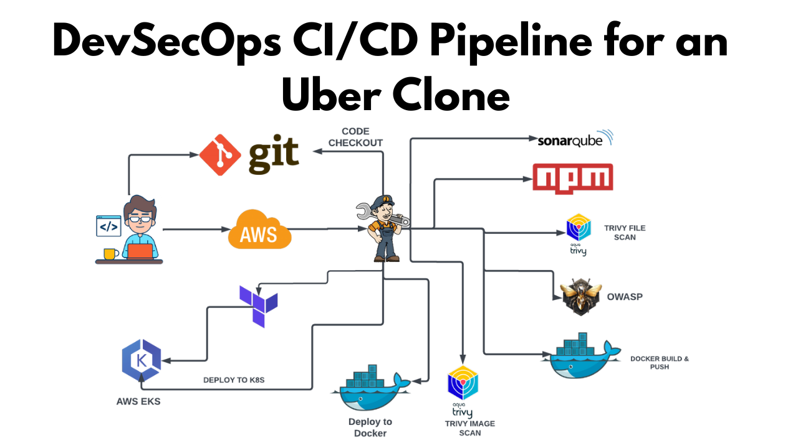

**GITHUB REPO: https://github.com/Venn1991/uber-clone.git**

**Step1: Launch an Ubuntu instance (T2.large)**

1. **Sign in to AWS Console:** Log in to your AWS Management Console.
2. **Navigate to EC2 Dashboard:** Go to the EC2 Dashboard by selecting “Services” in the top menu and then choosing “EC2” under the Compute section.
3. **Launch Instance:** Click on the “Launch Instance” button to start the instance creation process.
4. **Choose an Amazon Machine Image (AMI):** Select an appropriate AMI for your instance. For example, you can choose Ubuntu image.
5. **Choose an Instance Type:** In the “Choose Instance Type” step, select t2.large as your instance type. Proceed by clicking “Next: Configure Instance Details.”
6. **Configure Instance Details:**

* For “Number of Instances,” set it to 1 (unless you need multiple instances).
* Configure additional settings like network, subnets, IAM role, etc., if necessary.
* For “Storage,” click “Add New Volume” and set the size to 8GB (or modify the existing storage to 30GB).
* Click “Next: Add Tags” when you’re done.

1. **Add Tags (Optional):** Add any desired tags to your instance. This step is optional, but it helps in organizing instances.
2. **Configure Security Group:**

* Choose an existing security group or create a new one.
* Ensure the security group has the necessary inbound/outbound rules to allow access as required.

1. **Review and Launch:** Review the configuration details. Ensure everything is set as desired.
2. **Select Key Pair:**

* Select “Choose an existing key pair” and choose the key pair from the drop down.
* Acknowledge that you have access to the selected private key file.
* Click “Launch Instances” to create the instance.

1. **Access the EC2 Instance:** Once the instance is launched, you can access it using the key pair and the instance’s public IP or DNS.

Ensure you have necessary permissions and follow best practices while configuring security groups and key pairs to maintain security for your EC2 instance.

**STEP 2: Create IAM role**

Search for IAM in the search bar of AWS and click on roles.

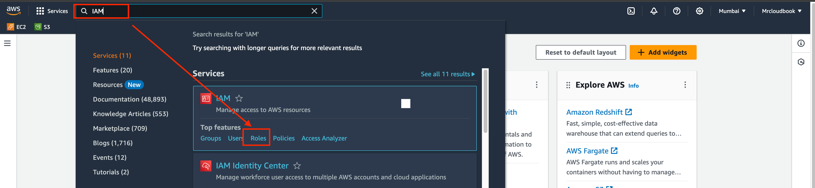

Click on Create Role

Select entity type as AWS service

Use case as EC2 and click on Next.

For permission policy select Administrator Access (Just for learning purpose), click Next.

Provide a Name for Role and click on Create role.

Role is created.

Now Attach this role to Ec2 instance that we created earlier, so we can provision cluster from that instance.

Go to EC2 Dashboard and select the instance.

Click on Actions –> Security –> Modify IAM role.

Select the Role that created earlier and click on Update IAM role.

Connect the instance to Mobaxtreme or Putty

**Step3: Installations of Packages**

create shell script in Ubuntu ec2 instance

sudo su #run from inside root

vi script1.sh

Enter this script into it  
This script installs Jenkins, Docker , Kubectl, Terraform, AWS Cli, Sonarqube

#!/bin/bash

sudo apt update -y

wget -O - https://packages.adoptium.net/artifactory/api/gpg/key/public | tee /etc/apt/keyrings/adoptium.asc

echo "deb [signed-by=/etc/apt/keyrings/adoptium.asc] https://packages.adoptium.net/artifactory/deb $(awk -F= '/^VERSION_CODENAME/{print$2}' /etc/os-release) main" | tee /etc/apt/sources.list.d/adoptium.list

sudo apt update -y

sudo apt install temurin-17-jdk -y

/usr/bin/java --version

curl -fsSL https://pkg.jenkins.io/debian-stable/jenkins.io-2023.key | sudo tee /usr/share/keyrings/jenkins-keyring.asc > /dev/null

echo deb [signed-by=/usr/share/keyrings/jenkins-keyring.asc] https://pkg.jenkins.io/debian-stable binary/ | sudo tee /etc/apt/sources.list.d/jenkins.list > /dev/null

sudo apt-get update -y

sudo apt-get install jenkins -y

sudo systemctl start jenkins

#install docker

# Add Docker's official GPG key:

sudo apt-get update

sudo apt-get install ca-certificates curl gnupg -y

sudo install -m 0755 -d /etc/apt/keyrings

curl -fsSL https://download.docker.com/linux/ubuntu/gpg | sudo gpg --dearmor -o /etc/apt/keyrings/docker.gpg

sudo chmod a+r /etc/apt/keyrings/docker.gpg

# Add the repository to Apt sources:

echo \

"deb [arch=$(dpkg --print-architecture) signed-by=/etc/apt/keyrings/docker.gpg] https://download.docker.com/linux/ubuntu \

$(. /etc/os-release && echo "$VERSION_CODENAME") stable" | \

sudo tee /etc/apt/sources.list.d/docker.list > /dev/null

sudo apt-get update

sudo apt-get install docker-ce docker-ce-cli containerd.io docker-buildx-plugin docker-compose-plugin -y

sudo usermod -aG docker ubuntu

newgrp docker

Now provide executable permissions to shell script

chmod 777 script1.sh

sh script1.sh

Let’s Run the second script

vi script2.sh

Add this script

#!/bin/bash

# install trivy

sudo apt-get install wget apt-transport-https gnupg lsb-release -y

wget -qO - https://aquasecurity.github.io/trivy-repo/deb/public.key | gpg --dearmor | sudo tee /usr/share/keyrings/trivy.gpg > /dev/null

echo "deb [signed-by=/usr/share/keyrings/trivy.gpg] https://aquasecurity.github.io/trivy-repo/deb $(lsb_release -sc) main" | sudo tee -a /etc/apt/sources.list.d/trivy.list

sudo apt-get update

sudo apt-get install trivy -y

#install terraform

sudo apt install wget -y

wget -O- https://apt.releases.hashicorp.com/gpg | sudo gpg --dearmor -o /usr/share/keyrings/hashicorp-archive-keyring.gpg

echo "deb [signed-by=/usr/share/keyrings/hashicorp-archive-keyring.gpg] https://apt.releases.hashicorp.com $(lsb_release -cs) main" | sudo tee /etc/apt/sources.list.d/hashicorp.list

sudo apt update && sudo apt install terraform

#install Kubectl on Jenkins

sudo apt update

sudo apt install curl -y

curl -LO https://dl.k8s.io/release/$(curl -L -s https://dl.k8s.io/release/stable.txt)/bin/linux/amd64/kubectl

sudo install -o root -g root -m 0755 kubectl /usr/local/bin/kubectl

kubectl version --client

#install Aws cli

curl "https://awscli.amazonaws.com/awscli-exe-linux-x86_64.zip" -o "awscliv2.zip"

sudo apt-get install unzip -y

unzip awscliv2.zip

sudo ./aws/install

Now

chmod 777 script2.sh

sh script2.sh

Now check the versions of packages

docker --version

trivy --version

aws --version

terraform --version

kubectl version

Provide executable permissions from Mobaxtreme

sudo chmod 777 /var/run/docker.sock

docker run -d --name sonar -p 9000:9000 sonarqube:lts-community

**Step4: Connect to Jenkins and Sonarqube**

Now copy the public IP address of ec2 and paste it into the browser

<Ec2-ip:8080> #you will Jenkins login page

Connect your Instance to Putty or Mobaxtreme and provide the below command for the Administrator password

sudo cat /var/lib/jenkins/secrets/initialAdminPassword



Now, install the suggested plugins.

Jenkins will now get installed and install all the libraries.

Create an admin user

Click on save and continue.

Jenkins Dashboard

Now Copy the public IP again and paste it into a new tab in the browser with 9000

<ec2-ip:9000> #runs sonar container

Enter username and password, click on login and change password

username admin

password admin

Update New password, this is Sonar Dashboard.

**Step5: Terraform plugin install and EKS provision**

Now go to Jenkins and add a terraform plugin to provision the AWS EKS using the Pipeline Job.

Go to Jenkins dashboard –> Manage Jenkins –> Plugins

Available Plugins, Search for Terraform and install it.

Go to Putty and use the below command

let’s find the path to our Terraform (we will use it in the tools section of Terraform)

which terraform

Now come back to Manage Jenkins –> Tools

Add the terraform in Tools

Apply and save.

CHANGE YOUR S3 BUCKET NAME IN THE [BACKEND.TF](http://backend.tf/)

Now create a new job for the EKS provision

I want to do this with build parameters to apply and destroy while building only.

you have to add this inside job like the below image

Let’s add a pipeline

pipeline{

agent any

stages {

stage('Checkout from Git'){

steps{

git branch: 'main', url: 'https://github.com/Venn1991/uber-clone.git'

}

}

stage('Terraform version'){

steps{

sh 'terraform --version'

}

}

stage('Terraform init'){

steps{

dir('EKS_TERRAFORM') {

sh 'terraform init'

}

}

}

stage('Terraform validate'){

steps{

dir('EKS_TERRAFORM') {

sh 'terraform validate'

}

}

}

stage('Terraform plan'){

steps{

dir('EKS_TERRAFORM') {

sh 'terraform plan'

}

}

}

stage('Terraform apply/destroy'){

steps{

dir('EKS_TERRAFORM') {

sh 'terraform ${action} --auto-approve'

}

}

}

}

}

Let’s apply and save and Build with parameters and select action as apply

Stage view it will take max 10mins to provision

Check in Your Aws console whether it created EKS or not.

Ec2 instance is created for the Node group

**Step6: Plugins installation & setup (Java, Sonar, Nodejs, owasp, Docker)**

Go to Jenkins dashboard

Manage Jenkins –> Plugins –> Available Plugins

Search for the Below Plugins

Eclipse Temurin installer

Sonarqube Scanner

NodeJs

Owasp Dependency-Check

Docker

Docker Commons

Docker Pipeline

Docker API

Docker-build-step

**Step7: Configure in Global Tool Configuration**

Goto Manage Jenkins → Tools → Install JDK(17) and NodeJs(16)→ Click on Apply and Save

For Sonarqube use the latest version

For Owasp use the 6.5.1 version

Use the latest version of Docker

Click apply and save.

**Step8: Configure Sonar Server in Manage Jenkins**

Grab the Public IP Address of your EC2 Instance, Sonarqube works on Port 9000, so <Public IP>:9000. Goto your Sonarqube Server. Click on Administration → Security → Users → Click on Tokens and Update Token → Give it a name → and click on Generate Token

click on update Token

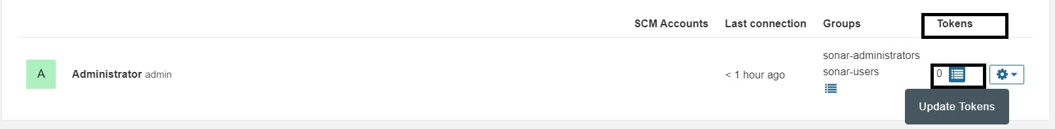

Create a token with a name and generate

copy Token

Goto Jenkins Dashboard → Manage Jenkins → Credentials → Add Secret Text. It should look like this

You will this page once you click on create

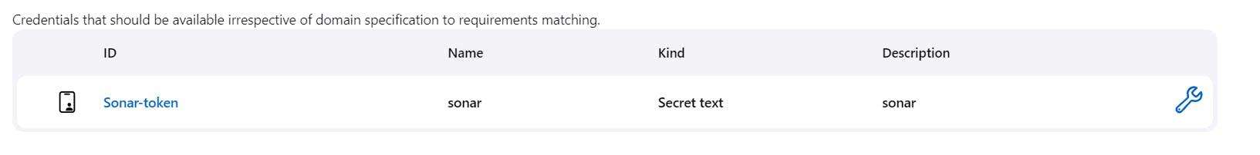

Now, go to Dashboard → Manage Jenkins → System and Add like the below image.

Click on Apply and Save

In the Sonarqube Dashboard add a quality gate also

Administration–> Configuration–>Webhooks

Click on Create

Add details

#in url section of quality gate

<http://jenkins-public-ip:8080>/sonarqube-webhook/>

Now add Docker credentials to the Jenkins to log in and push the image

Manage Jenkins –> Credentials –> global –> add credential

Add DockerHub Username and Password under Global Credentials

Create.

**Step09: Pipeline upto Docker**

Now let’s create a new job for our pipeline

Add this to Pipeline

pipeline{

agent any

tools{

jdk 'jdk17'

nodejs 'node16'

}

environment {

SCANNER_HOME=tool 'sonar-scanner'

}

stages {

stage('clean workspace'){

steps{

cleanWs()

}

}

stage('Checkout from Git'){

steps{

git branch: 'main', url: 'https://github.com/Venn1991/uber-clone.git'

}

}

stage("Sonarqube Analysis "){

steps{

withSonarQubeEnv('sonar-server') {

sh ''' $SCANNER_HOME/bin/sonar-scanner -Dsonar.projectName=Uber \

-Dsonar.projectKey=Uber'''

}

}

}

stage("quality gate"){

steps {

script {

waitForQualityGate abortPipeline: false, credentialsId: 'Sonar-token'

}

}

}

stage('Install Dependencies') {

steps {

sh "npm install"

}

}

stage('OWASP FS SCAN') {

steps {

dependencyCheck additionalArguments: '--scan ./ --disableYarnAudit --disableNodeAudit', odcInstallation: 'DP-Check'

dependencyCheckPublisher pattern: '**/dependency-check-report.xml'

}

}

stage('TRIVY FS SCAN') {

steps {

sh "trivy fs . > trivyfs.txt"

}

}

stage("Docker Build & Push"){

steps{

script{

withDockerRegistry(credentialsId: 'docker', toolName: 'docker'){

sh "docker build -t uber ."

sh "docker tag uber devopsvmr/uber:latest "

sh "docker push devopsvmr/uber:latest "

}

}

}

}

stage("TRIVY"){

steps{

sh "trivy image devopsvmr/uber:latest > trivyimage.txt"

}

}

stage("deploy_docker"){

steps{

sh "docker run -d --name uber -p 3000:3000 devopsvmr/uber:latest"

}

}

}

}

Click on Apply and save.

Build now

Stage view

To see the report, you can go to Sonarqube Server and go to Projects.

You can see the report has been generated and the status shows as passed. You can see that there are 1.2k lines it scanned. To see a detailed report, you can go to issues.

OWASP, you will see that in status, a graph will also be generated and Vulnerabilities.

When you log in to Dockerhub, you will see a new image is created

**Step10: Kubernetes Deployment**

Go to Putty of your Jenkins instance SSH and enter the below command

aws eks update-kubeconfig --name <CLUSTER NAME> --region <CLUSTER REGION>

aws eks update-kubeconfig --name EKS_CLOUD --region ap-south-1

Let’s see the nodes

kubectl get nodes

Copy the config file to Jenkins master or the local file manager and save it

copy it and save it in documents or another folder save it as secret-file.txt

Note: create a secret-file.txt in your file explorer save the config in it and use this at the kubernetes credential section.

Install Kubernetes Plugin, once it’s installed successfully

go to manage Jenkins –> manage credentials –> Click on Jenkins global –> add credentials

final step to deploy on the Kubernetes cluster

stage('Deploy to kubernets'){

steps{

script{

dir('K8S') {

withKubeConfig(caCertificate: '', clusterName: '', contextName: '', credentialsId: 'k8s', namespace: '', restrictKubeConfigAccess: false, serverUrl: '') {

sh 'kubectl apply -f deployment.yml'

sh 'kubectl apply -f service.yml'

}

}

}

}

}

You will see output like this.

**Step11: Destruction**

Now Go to Jenkins Dashboard and click on Terraform-Eks job

And build with parameters and destroy action

It will delete the EKS cluster that provisioned

After 10 minutes cluster will delete and wait for it. Don’t remove ec2 instance till that time.

Cluster deleted

Delete the Ec2 instance.